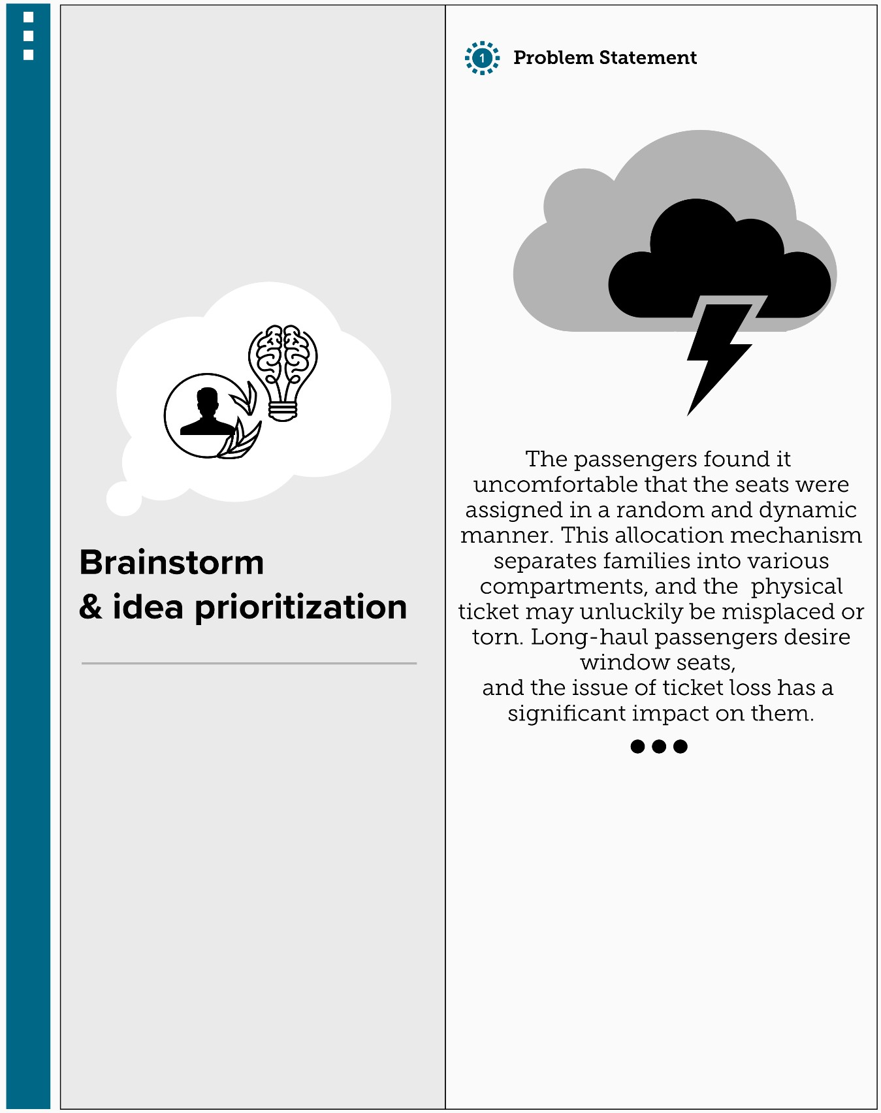**Brainstorm & Idea Prioritization: Step-1: Problem Statement**

Step-2: Brainstorm

Kavi Bharathi

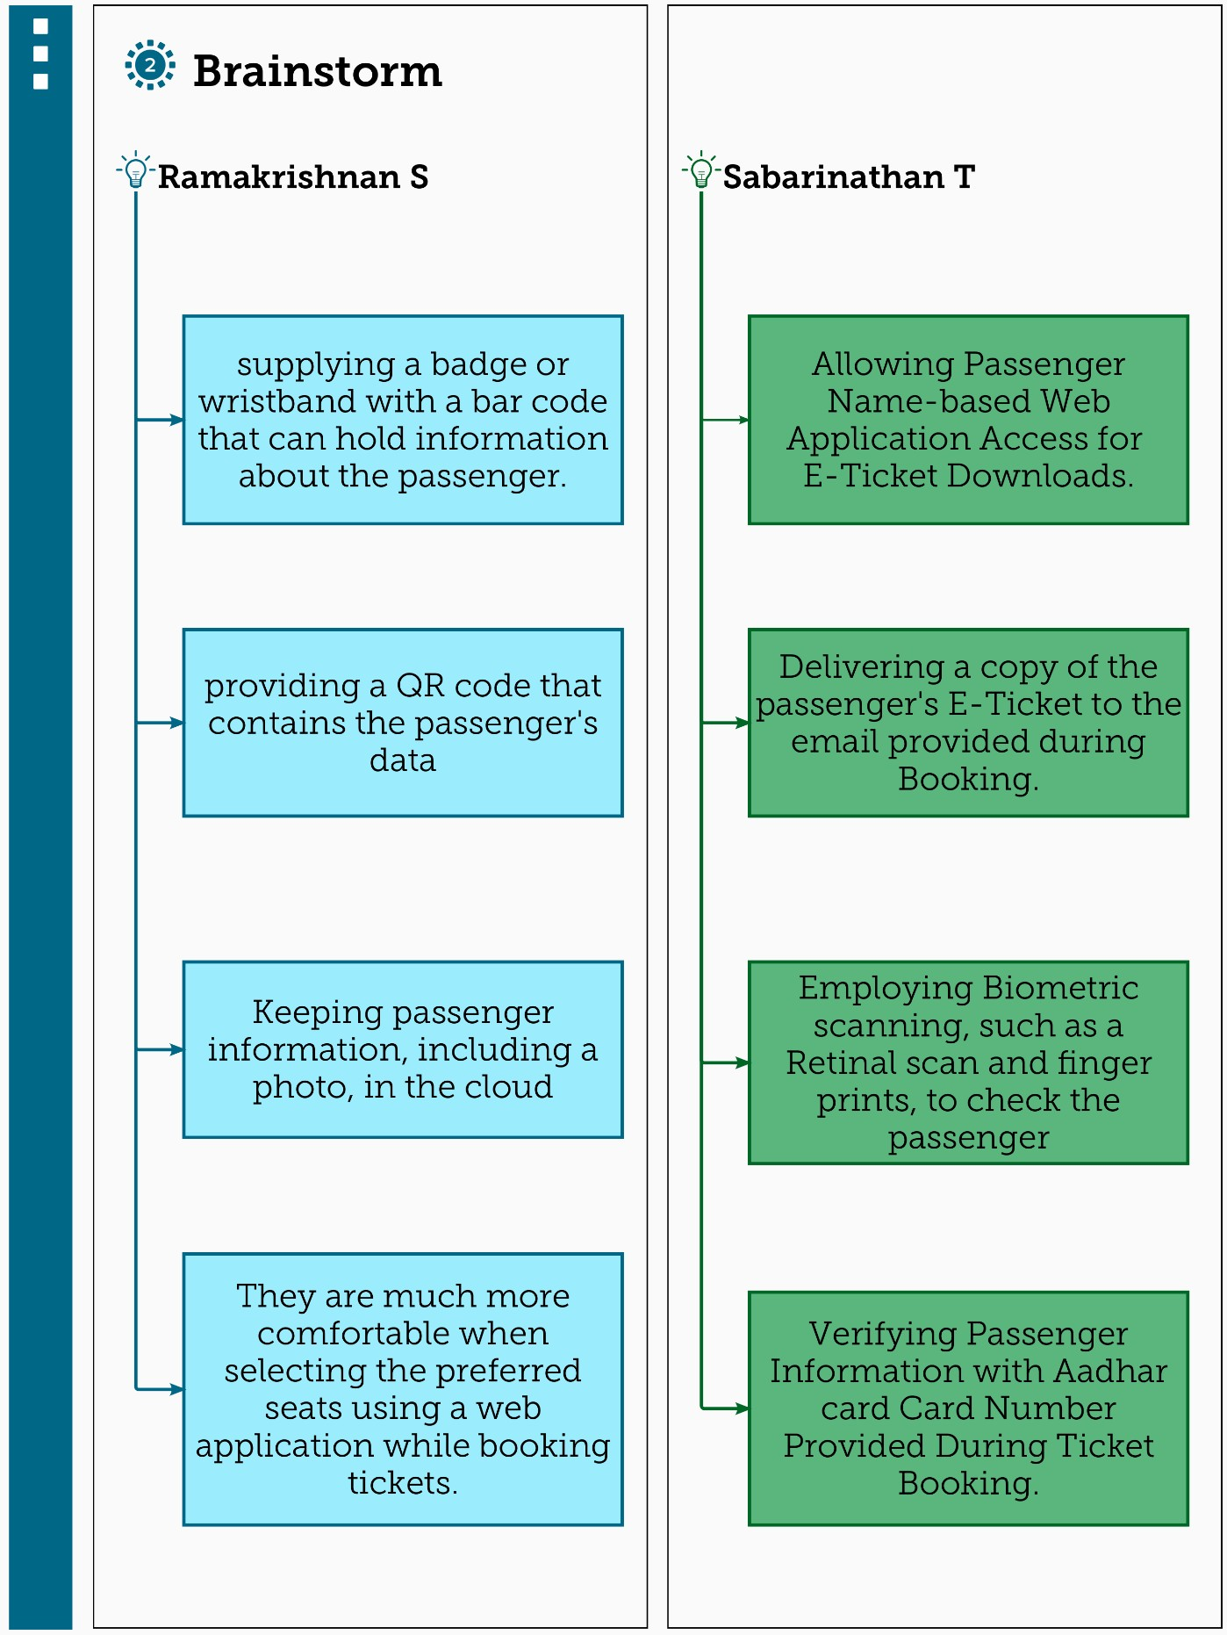

Jayalakshmi

Ghunavarthini Visiranthi

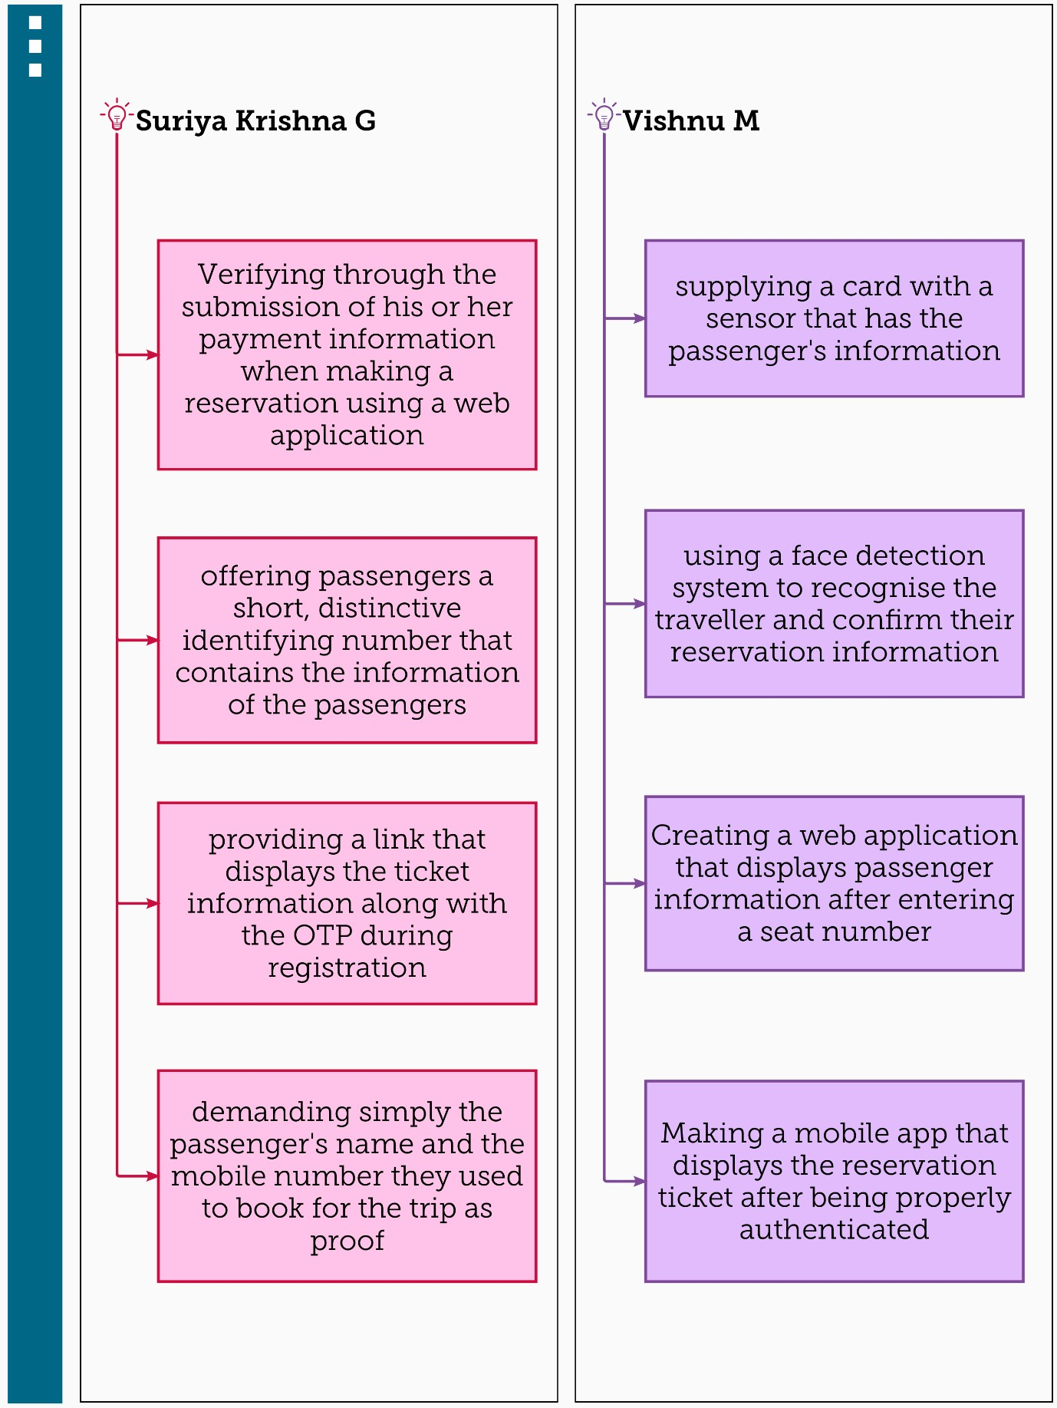

Step-3: Idea Grouping

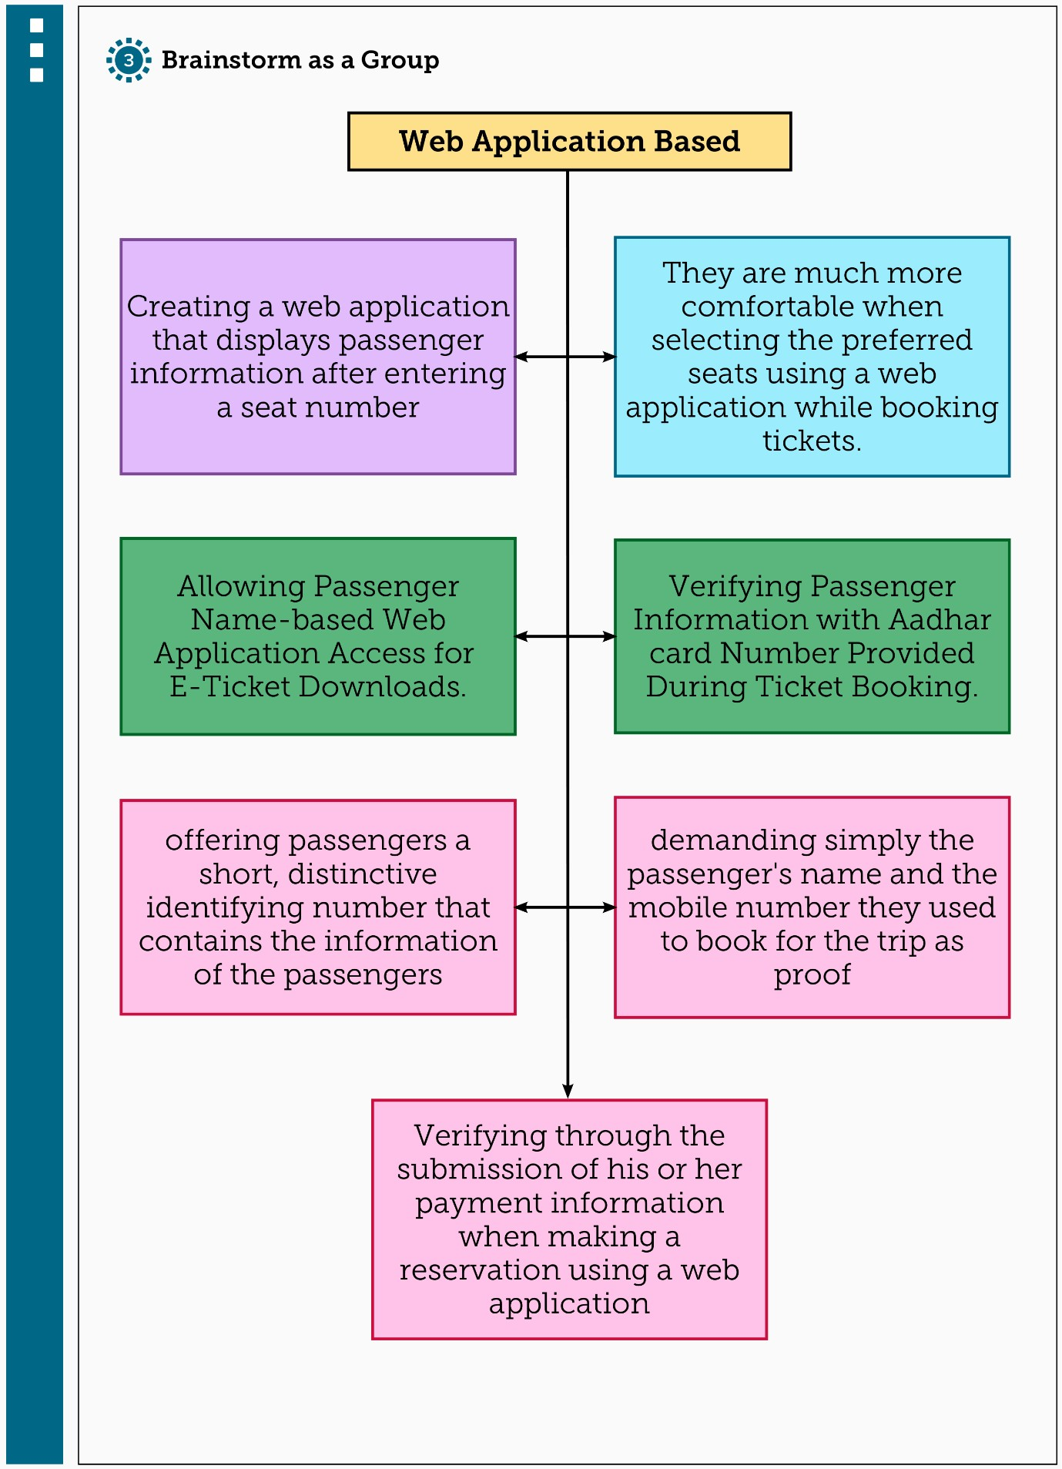

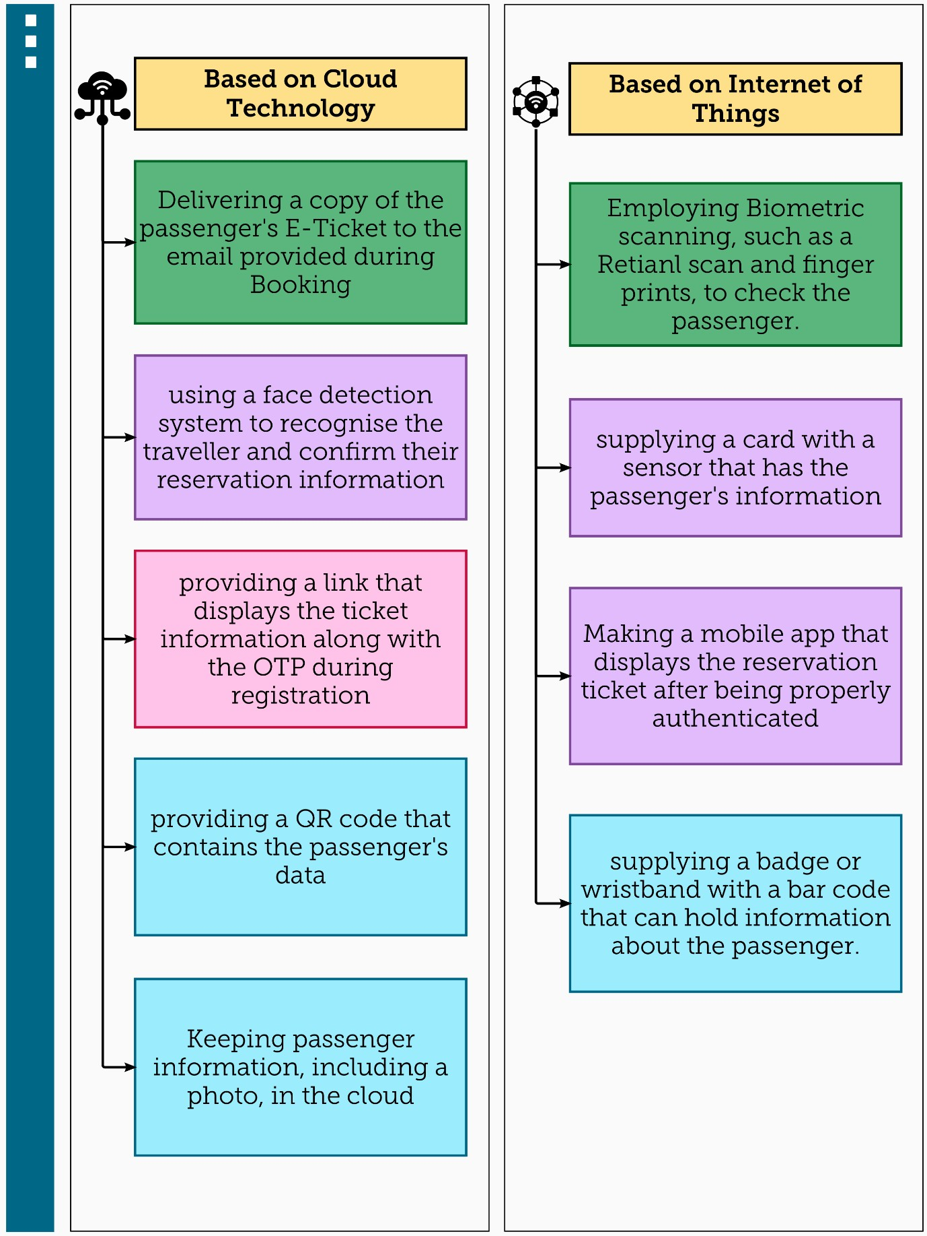

Step-4: Idea Prioritization

